 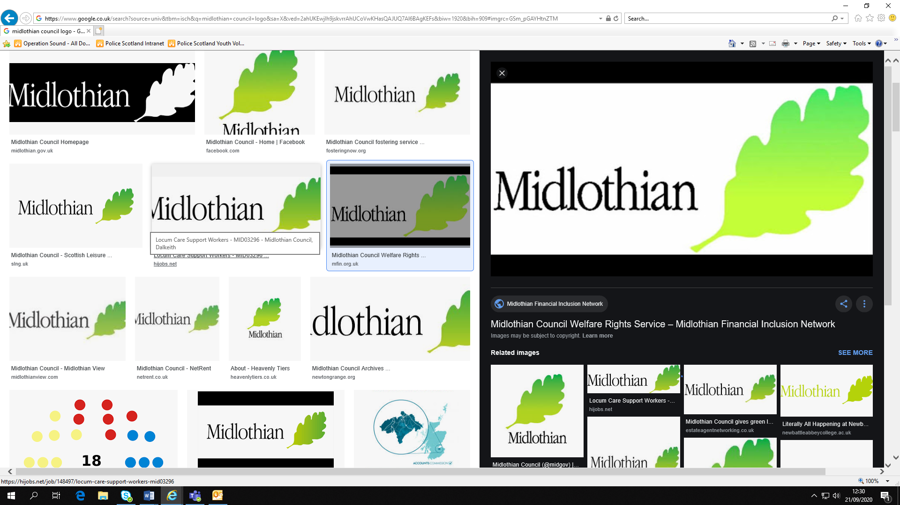 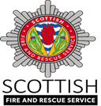

Dear Parents/Guardians,

In the run up to bonfire season, Police Scotland, Midlothian Council and Scottish Fire & Rescue are keen to keep everyone safe during the festivities. In previous years we have seen firework-related anti-social behaviour (ASB) and disorder in this area, and we are asking for your help to prevent this occurring again. This year, we are also facing the added challenge of preventing the spread of COVID 19 within our communities. As a result organised fireworks displays and bonfires are unlikely to be permitted. Please ensure your children and young people follow current COVID 19 guidelines. These can be found at <https://www.gov.scot/coronavirus-covid-19/>

We are offering the following advice to stay safe this fireworks night:

* Unless supervised by an adult, please do not allow your children or young people to handle, purchase or set off fireworks.
* Do not allow your children or young people to be involved in or accompany anyone who is involved in ASB or disorder.
* Please report any ASB or disorder you are aware of or hear of.
* Dispose of your rubbish appropriately leading up to bonfire weekend.
* Please report any unauthorised fireworks sellers to Police or anonymously to Crimestoppers
* Please report any known unauthorised bonfires or firework displays by calling:
  + Midlothian Council, 0131 270 7500
  + Police Scotland, 101
  + Crimestoppers, 0800 555 111

Unauthorised bonfires and firework displays have resulted in serious harm and injury in the past. Further bonfire safety advice can be found here <https://www.firescotland.gov.uk/your-safety/bonfire-safety.aspx>

**Legislation**

* No person under the age of 18 can possess an adult* firework in a public place
* It is an offence to supply adult* fireworks to persons under 18
* It is an offence to supply *any* fireworks to persons under 16
* It is an offence to throw fireworks on a road or other public place

***\*Adult firework*** *is any firework except for caps, cracker snaps, indoor fireworks, novelty matches, party poppers, serpents and throw downs.*

Those who choose to ignore current COVID 19 guidance and get involved in antisocial behaviour or disorder on or around the 5 November 2020 will be dealt with robustly and may also be subject to prosecution.

Please help us make sure that everyone has a safe and enjoyable bonfire night.

Thank you in advance for your understanding and assistance.

Kind regards,

**Police Scotland, Midlothian Council & Scottish Fire & Rescue Service**